|  |  |
| --- | --- |
| EGC_Black | Student Name \_\_\_\_\_\_\_\_\_\_\_\_\_\_\_\_\_\_\_\_\_\_\_  **Eastern Goldfields College**  Mathematics Methods 2016  Test 211– Calculator Free Section |
| Working Time: 20 minutes | Total Marks: 19 marks |

1. [5 marks – 2, 2, 1]

(a) Evaluate $\frac{12!}{5!×8!}$

(b) Determine the sum of $\left(\begin{matrix}6 \\ 0\end{matrix}\right)$ + $\left(\begin{matrix}6 \\ 1\end{matrix}\right)$ + $\left(\begin{matrix}6 \\ 2\end{matrix}\right)$ + $\left(\begin{matrix}6 \\ 3\end{matrix}\right)$ + $\left(\begin{matrix}6 \\ 4\end{matrix}\right)$ + $\left(\begin{matrix}6 \\ 5\end{matrix}\right)$ + $\left(\begin{matrix}6 \\ 6\end{matrix}\right)$

(c) The function $h$ is given by $h\left(x\right)=2{\left(x+3\right)}^{2}-1$.

Determine the $x$-coefficient of the expanded form of this polynomial.

2. [7 marks – 1, 1, 1, 1, 3]

(a) A polynomial is given by $5-x+2x^{2}-4x^{3}+x^{4}$.

1. State the degree of the polynomial.
2. Determine the sum of all the coefficients of this polynomial.

(b) A row of Pascal’s Triangle starts with the numbers 1, 5, 10, …

1. Write down the numbers that complete the row.
2. Express the sum of all the numbers in the row as a power of 2.

2. [continued]

(iii) Expand

3. [7 marks – 2, 2, 3]

1. Expand $\left(2x+1\right)\left(x+1\right)\left(2x-1\right)$
2. The graph of $y=2x^{3}-13x^{2}+22x-8$ is shown below

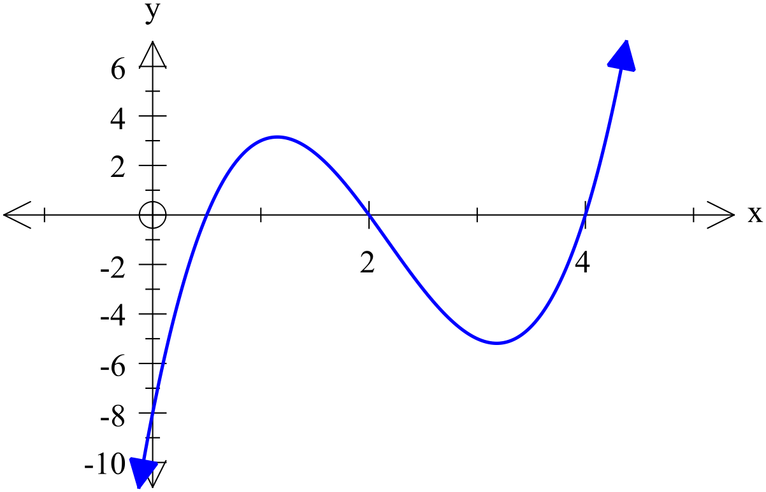

Factorise

1. Solve

|  |  |
| --- | --- |
| EGC_Black | Student Name \_\_\_\_\_\_\_\_\_\_\_\_\_\_\_\_\_\_\_\_\_\_\_  **Eastern Goldfields College**  Mathematics Methods 2016  Test 11– Calculator Assumed Section |
| Working Time: 40 minutes | Total Marks: 40 marks |

4. [1, 1, 1, 1, 2, 1, 2, 2, 1 – 12 marks]

1. Let Set *A* be defined as $A=\left\{x:x is a positive integer less than 10\right\}$.
2. State $n(A)$.
3. Explain whether the statement $0∈A$ is true or false.

1. Let Set *B* = $\left\{1, 2, 3, 4\right\}$. An integer is formed by choosing two digits, at random

and without repetition, from *B.*

1. List the sample space in a systematic way.
2. Determine the probability that the integer formed is a prime number.
3. Determine the probability that the integer formed is even, given that it is

a multiple of three.

1. Determine the number of ways in which a shortlist of 5 photographs can be

chosen from a set of 20 different photographs.

4. [continued]

1. Following a survey of the use of three council facilities it was found that 31

people had used the library and 23 had used the aquatic centre. Of the 7 who had used both the aquatic centre and the library, 3 had also used the community centre. 10 people had only used the aquatic centre whilst 11 people had used the library and the community centre but not the aquatic centre. 29 of the 91 surveyed had used none of the facilities.

1. Complete the Venn diagram below to show this information, showing the number of the people in each region of the diagram.

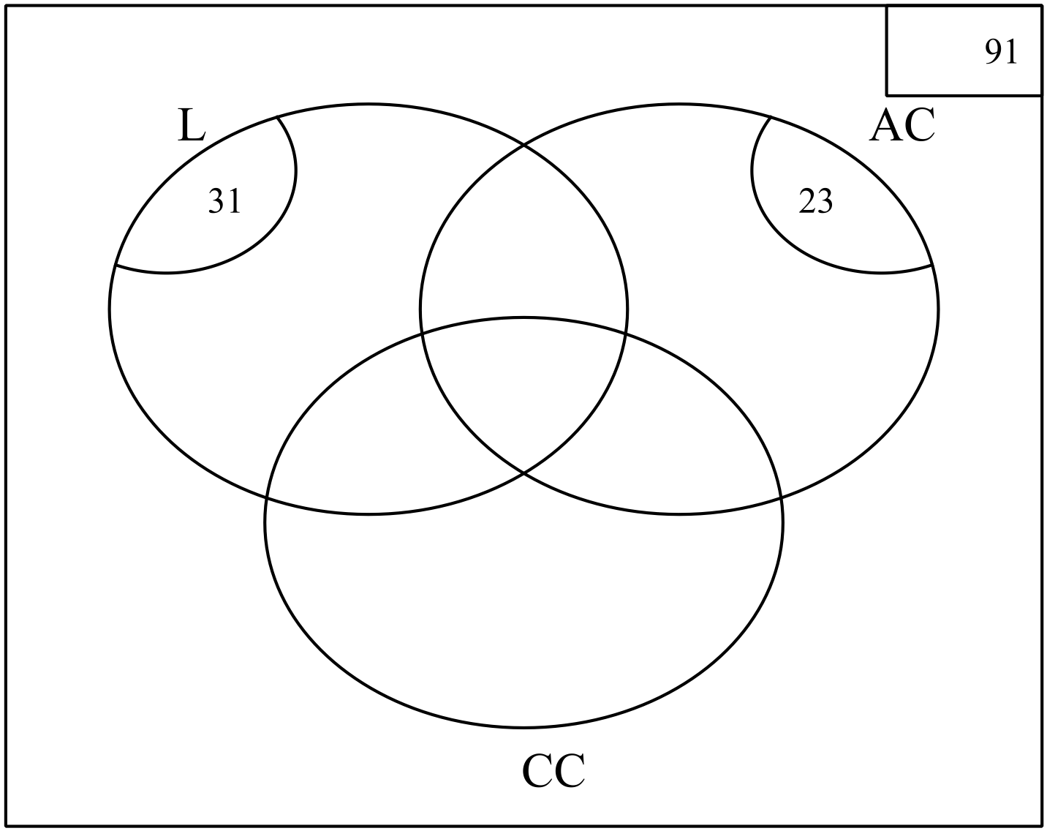

1. If one person surveyed was selected at random, what is the probability

that they used no more than two facilities if it was known that they had used at least one of the facilities?

1. Explain why using the library and using the aquatic centre are not

mutually exclusive.

5. [6 marks – 1, 1, 2, 2]

The probabilities of two events A and B are such that P(A) = *q* and P(A|B) = 0.6

Determine:

1. P(A) if the events A and B are independent.
2. P(B) if the events A and B are independent and P(A $∩$ B) = 0.18
3. P(A $∩$ B) if P(B) = 0.5

(d) The range of possible values of P(A) if P(B) = 0.5.

6. [7 marks – 2, 1, 2, 2]

Craig and Emily went to Interlaken in Switzerland for a white winter Christmas

holiday. As part of their itinerary, there is a sleigh ride scheduled for Christmas Day, 25th December, if there is enough snow on the ground.

The historical chance of snow on the ground on 25th December is 65%. If there is snow on the ground, then they are 95% certain to go on a sleigh ride that day. If there isn’t snow on the ground, then there is an 80% chance that an alternate activity will be organised.

1. Complete the tree diagram below to represent this situation.

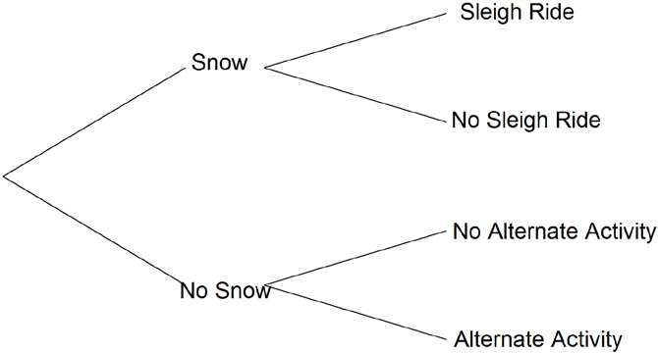

1. Calculate the probability that on the 25th December Craig and Emily:
2. go for a sleigh ride.
3. have no activity planned for the day.

(iii) experience snow on the ground given that they have no activity planned for that day.

7. [9 marks – 1, 2, 3, 1, 2]

Consider the function $f\left(x\right)=-2x^{3}-4x^{2}+10x+15$.

Use your calculator to answer the following questions, rounding your answers to two decimal places where appropriate.

(a) State the coordinates of the vertical intercept.

(b) Determine the turning points of $f\left(x\right)$ and their nature.

1. State the roots of $f(x)$

(d) How many solutions are there to the equation $f\left(x\right)$ = 10?

(e) For what values of *k* does the equation $f\left(x\right)$ = *k* have only one solution?

8. [6 marks – 1, 2, 3]

A piece of machinery is comprised of 4 components, each of which work independently

of the other three components.

The first and second components each have a 5% probability of failure. The third

component has a 2% probability of failure and the final component has a 1% chance of

failure.

The machine won’t work if **all** the components fail.

Calculate the probability that:

1. only the second component fails.
2. the machine will stop working.
3. at most one of the components fail.